**Editing Guide for the Abstract (Trebuchet MS 14, bold)**

First Author (First Name LAST NAME) 1, Second Author (First Name LAST NAME) 2*, etc. (Trebuchet MS 10)

1 institution name + complete and present-day postal address (Trebuchet MS 8)

* Corresponding author: professional e-mail address: (Trebuchet MS 8)

*Received*: Month 2024; *Accepted for publication*: Month 2024;

*Published*: September 2024; *Online at*: [www.icpe-ca/cem-2024/](http://www.icpe-ca/cem-2024/%20) (Trebuchet MS 8)

**Abstract (Trebuchet MS 12, bold)**

Abstract text (length: 450 - 500 words, Trebuchet MS 12).

**Keywords**: (max. 5 words, Trebuchet MS 10

**Bibliographic References** (Trebuchet MS 10)

# Typing

1. Copy the 2024-template-file_CEM 2024 in your PC.
2. Open the template file, select “Page Layout” from the “View” menu in the Menu bar (View | Page Layout).
3. Select all the text of your abstract and paste it into the new file.
4. Give a name to the file of your abstract.
5. Activate Show/Hide “¶” (Ctrl+*) at the low- right corner of the Paragraph group.
6. If you use **Microsoft 365** facilities: click the small icon ( Graphical user interface, text, application, Word  Description automatically generated  ) at the low-right corner of the Styles group.
7. Pay attention only to the Styles from CEM 2024_01 to CEM 2024_14.

Example:

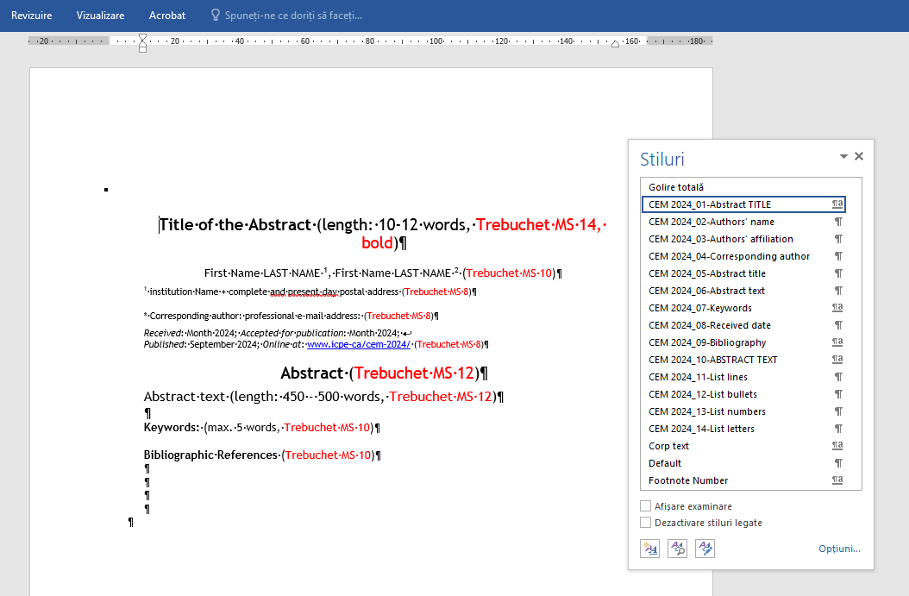

* Select “Abstract text” including “¶” and click on “CEM 2024_06-Abstract text 1.”
* The EEA Styles adjust your fonts and line spacing.
* Do not change the font sizes or line spacing of the file.

**Page size:**

A4 (210mm wide and 297mm long).

**Margins:**

* + Top = 24mm
  + Bottom = 18mm
  + Left = 25mm
  + Right = 20mm
* Maintain the 2 (two) columns of the text, with a space of 0.5mm between columns.
* All paragraphs must be indented and justified. The entire document should be in Trebuchet MS font.
* Do not insert Header/Footer texts and Page Numbers in the file.

# Editing Instructions

Use the British English Language.

The **Title of the Abstract** must be concise, informative, including a few details for indexing purposes and 1-2 keywords**,** written in uppercase and lowercase letters, not all uppercase**. Avoid**: acronyms, abbreviations, symbols, formulae, equations, figures, tables, references, etc., active verbs, expressions like "~~Study of~~ ...", "~~Contribution~~ ~~to~~..." "~~Observations on~~ ...", etc.

# Title length: 10 words - 12 words.

**Full Names** of the authors (First Name LAST NAME) are preferred. Write the same superscript number for the same institution.

The Authors’ **Current Affiliations**: Institution Name **+** complete and present-day postal address (written in English and, in Romanian, ONLY for the Romanian Institutions).

The **Corresponding Author** is identified with an asterisk (*).

The **Abstract** contains a very short introduction to the field, the background and purpose of the work; the main conclusions and how the results described in the article moved the field forwards.

**Avoid**: acronyms, abbreviations, symbols, formulae, mathematical equations, footnotes, Figures, Tables, numbered reference citations, etc. It must be written in a single paragraph. **Length: 400 - 500 words**.

**Keywords**: max. 5 words written in English and separated by commas.

**Avoid**: acronyms, abbreviations, symbols, formulae, mathematical equations, footnotes, Figures, Tables, numbered reference citations, etc.

Special Character Typing

• write with straight characters:

- symbols size, when using Greek letters;

- numerical value of physical quantities, when using Greek letters;

- chemical symbols;

- numeric indices from mathematical and chemical formulas;

- symbols of trigonometric functions: sin, cos, arcsin, sh;

- symbols of logarithms: log, lg, ln;

- temperature scale: °C, °R, °F, K;

- notation (d) for the differential;

- characteristic numbers (in variable or criteria): Re, Pr, No, Gr, Bi;

- operators: rot, div, grad, exp;

- dedicated functions: Bessel, Lagrange, Hamilton;

- symbols for: limit (lim), constant (Const.), integral (∫), imaginary number (i or j), base of natural logarithms (e);

- superscript and subscript indices, derived from abbreviations: min, max, avg, int, ext;

• write with *italics* characters:

- size symbols, when using *Latin letters*;

- literal symbol of physical quantities, when using *Latin letters*;

- variables: *x*, *y*, *z*;

- some functions: *f*, *g*, *f* (*x*), *v* (*t*);

- superscript and subscript indices as a symbol of physical quantities;

- literal coefficients and indices of chemical formulas: *n*C6H12O6, (C6H10O5)*x*;

- prefixes of chemical names: *A*-(ortho), *m*-(meta), *p*-(para), *trans*-;

- symbols for mass number *A* and atomic number *Z*;

- the concentration of hydrogen ions in solution: *pH*;

• write with **straight** and **bold** characters:

- **matrices in brackets**;

• write with ***italics*** and ***bold*** characters:

- ***vectors, tensors***.

# Bibliographic References

[Each bibliographic reference written in Trebuchet MS, 10]

*Take into account:*

1. min. 25 bibliographic references;
2. 70 % of articles issued after 2015;
3. >50 % of articles published in ISI journals.

Books:

LAST NAME (all letters uppercase)**,** First Names (Initial Letters) (for each author)**,** *Title of the book (in italics)***,** edition #**,** vol. #, revised by X**,** Place of publication: Publishing Company**,** year**.** (dot)

1. PARKER, T.J., HASWELL, W.A., *The heat flow network*, 6th ed., vol. 1, revised by O. LOWENSTEIN and vol. 2, revised by C. FORSTER-COOPER, London: Macmillan, 1940**.**

A chapter from a book:

1. Young, G.O., “Synthetic structure of industrial plastics”, in *Plastics,* vol. 3: *Polymers of Hexadromicon*, J. Peters Editor, ed. 2, New York: McGraw-Hill, 1964, pp. 15-64**.**

A translated book:

1. Sartre, J.-P., Being and Nothingness: An Essay on Phenomenological Ontology [*L’Être et le néant: Essai d’ontologie phénoménologique*], translated from the French by Hazel E. Barnes, London: Routledge, 1969**.**

Periodicals:

LAST NAME (all letters uppercase)**,** First Names (Initial letters) (for each author)**, “**Title of the article (between quotations marks)” (Title translated in English, if the article is written in Romanian or French)**,** *Name of the Journal (in italics)***,** year, vol**.** #**,** issue #**,** pp. (page numbers)**,** print ISSN and/or online ISSN**.** (dot)

1. CICEO, S., MOLLET, Y., SARRAZIN, M., VAN DER AUWERAER, H., MARȚIȘ, C.S., “Model-based design and testing for the energy consumption analysis of the electric vehicles”, *Electrotehnica, Electronica, Automatica (EEA)*, 2017, vol. 65, no. 1, pp. 46-51, ISSN 1582-5175**.**

An article written in Romanian:

1. LINGVAY, I., OPRINA, G., MARINESCU, V., MITREA, S.,

„Comportarea cuprului de uz electrotehnic în uleiuri de transformator expuse ciclărilor termice” (Behaviour of electrical purposes copper in thermal cycled transformer oils), in: *Electrotehnica, Electronica, Automatica (EEA)*, 2017, vol. 65, no. 1, pp. 5-10, ISSN 1582-5175**.**

Communications published in Proceedings:

LAST NAME (all letters uppercase)**,** First Names (Initial letters) (for each author)**, “**Title of the article (between quotations marks)”**, in:** Proceedings of the (Name of the Conference)**,** Place**,** Country**,** date (days Month year)**,** Place of publication: Publishing Company**,** year**,** pp. (page numbers)**.** (dot)

1. Militaru T.L., Suciu G., Todoran G., “The Use of expert systems in building the quality model of a web-based learning platform”, in: Proceedings of the 11th International Conference “Advances in web-based Learning (ICWL 2012)”, Sinaia, România, 2-4 Sept. 2012, Berlin, Heidelberg: Springer**,** 2012, pp. 318-327**.**

An Internet document:

LAST NAME (all letters uppercase)**,** First Names (Initial Letters) (for each author)**,** *Title of the document (in italics)***,** viewed on: (day Month year)**,** retrieved from: (URL complete) (NO punctuation mark at the end!)

1. REITZ, Joan M. ODLIS., *Online Dictionary for Library and Information Science*, viewed on 10 august 2017, retrieved form: <http://lu.com/odlis/index.cfm>

Standards:

Name of the Standardization Institution**,** number of the standard**:** publication year**,** Name of the standard *(in italics)***.** (dot)

1. ISO 3297: 2007, *Information and documentation. International standard serial number (ISSN)***.**

Patents:

Name of Institution**,** *Title of Patent (in italics)***,** inventor(s): LAST NAME (all letters uppercase)**,** First Names (Initial Letters)**,** date, country **and** number of patent**.** (dot)

1. Rhône-Poulenc Biochimie, *Cellules modifiées au niveau du catabolisme de la bétaine, préparation et utilisations, notamment pour la production de métabolites ou d'enzymes*, inventors: CAMERON B., CROUZET J., 04 Jan. 2006, European Patent EP 0 673 422 B1**.**
2. WINGET Ltd., *Detachable bulldozer attachment for dumper vehicles*, inventor: ENGLAND, R.J., 1967, GB Patent: 1060631.

**Citations***:*

* + shorter than 3 rows: they are written between quotation marks in the same phrase;
  + longer than 3 rows: they are written as a separate paragraph, 1 cm indentation to the right, one blank line above and below, and without quotation marks.

*Mention of a reference in the text (its number into square brackets):*

“… as the author mentioned in his most recent work [1] about the heat flow network … “.

The same reference is written in the Bibliographic Reference List:

[1] PARKER, T.J., HASWELL, W.A., *The heat flow network*. 6th ed., vol. 1 (revised by O. LOWENSTEIN), and vol. 2 (revised by C. FORSTER-COOPER), London: Macmillan, 1940**.**

Multiple bibliographic references in a sentence

The reference number is placed near to the referred ideas.

A statement may contain:

*max. 3 (three) single numbers of references* or

*max. 4(four) grouped numbers of references*.

Write each reference number between brackets. Write a comma after each single or grouped reference.

In a group of references, separate the first reference number from the last one with a dash.

Examples:

…as shown by Brown [3] and Smith [23], …

…as demonstrated in [4], [11], [20].

…according to [5]–[8], [17], …